# System Implementation & Test (SIT)

## Introduction

### System Overview

This section provides in detail all necessary information about test plans, test cases, test result, test environments, pass/fail criteria and risks estimations as well as a checklist to cover all possible cases of ORS system.

### Test Approach

Goal: Check all the features in ORS system and record remain bug to fix.

Type: White box testing, Black-box testing.

Size: System Component.

Technique: Check list.

## Database Relationship Diagram

### Physical Diagram

### Data Dictionary

## Performance Measures

### Clustering Performance

## Test Plan

### Features to be tested

We will carry out test based on core workflow of system. All main functions will be tested carefully and clearly following phases.

* Guest:
* Customer:
* Admin:
* Manager:
* Staff

### Features not to be tested

* Login, Logout.

## System Testing Test Case

### Customer Test Case

#### Request Office

|  |  |  |  |  |  |  |  |
| --- | --- | --- | --- | --- | --- | --- | --- |
| **ID** | **Test Case Description** | **Test Case Procedure** | **Inter-test Case Dependence** | **Expected output** | **Result** | **Test Date** | **Note** |
| 01 | Send request office | 1. Choose “Đặt yêu cầu văn phòng” on home page. 2. Login as role customer.      1. Select “Loại văn phòng” is: “Tòa nhà văn phòng”. 2. Input “Giá” “310000” 3. Input “Diện tích”: 12 4. Input “Quận”: Quận 4 5. Input “Danh sách tiện nghi”: Thang máy 6. Click “Đặt văn phòng” button | * N/A | * Show successful message ” 'Đặt yêu cầu thành công” * Transform to home page * Click to “Yêu cầu văn phòng của bạn” and request has been shown | Passed | 8/8/2015 |  |

Table : Request Office

### Manager Test Case

#### Create Contract

|  |  |  |  |  |  |  |  |
| --- | --- | --- | --- | --- | --- | --- | --- |
| **ID** | **Test Case Description** | **Test Case Procedure** | **Inter-test Case Dependence** | **Expected output** | **Result** | **Test Date** | **Note** |
| 01 | Create contract | 1. Login as manager role 2. Click to “Lịch hẹn mới” on home page 3. Click to tab “chấp nhận” on tab bar 4. Click button “Đến ký/ Hủy hợp đồng” 5. Click “Tạo hợp đồng” button 6. Input “Ngày bắt đầu”: 08-08-2015 7. Input “Thời gian thuê”: 6 8. Select “Kỳ hạn thanh toán”: 3 tháng 9. Input “Giá thuê”: 250000 10. Input “Tiền đặt cọc”: 5000000 11. Click “Tạo mới” button | * Confirm appointment | * After step 4: Show detail appointment * Transform to contract list page * New contract has been shown in contract list page | Passed | 8/8/2015 |  |

Table : Create contract

#### Edit Contract

|  |  |  |  |  |  |  |  |
| --- | --- | --- | --- | --- | --- | --- | --- |
| **ID** | **Test Case Description** | **Test Case Procedure** | **Inter-test Case Dependence** | **Expected output** | **Result** | **Test Date** | **Note** |
| 01 | Edit Contract | 1. Login as manager role 2. Click to “Tổng hợp đồng” on home page 3. Click to button “chi tiết” 4. Click “Chỉnh sửa” button 5. Click to tab “chấp nhận” on tab bar 6. Click button “Đến ký/ Hủy hợp đồng” 7. Click “Tạo hợp đồng” button 8. Input “Ngày bắt đầu”: 09-09-2015 9. Input “Thời gian thuê”: 12 10. Select “Kỳ hạn thanh toán”: 3 tháng 11. Input “Giá thuê”: 250000 12. Input “Tiền đặt cọc”: 7500000 13. Click “Tạo mới” button | * Create contract | * After step 3: show detail of the contract * Transform to contract list page * The contract has been update | Passed | 8/8/2015 |  |

Table : Edit contract

### System

#### Check request office

|  |  |  |  |  |  |  |  |
| --- | --- | --- | --- | --- | --- | --- | --- |
| **ID** | **Test Case Description** | **Test Case Procedure** | **Inter-test Case Dependence** | **Expected output** | **Result** | **Test Date** | **Note** |
| 01 | Check request office | 1. Create request office on customer role 2. Login as customer role 3. Select “Tòa nhà văn phòng” on “Loại văn phòng” 4. Input “Giá”: 350000 5. Input “Diện tích”: 150 6. Input “Quận”: Quận 10 7. Input “Danh sách tiện nghi”: Phòng vệ sinh 8. Click “Đặt văn phòng” | * Create request office | * After one day, click to “Yêu cầu văn phòng của bạn”. The request has been shown and the office “RIVER VIEW TOWER” will be list at the bottom page | Passed | 8/8/2015 |  |

Table : Check request office

#### Check contract due date

|  |  |  |  |  |  |  |  |
| --- | --- | --- | --- | --- | --- | --- | --- |
| **ID** | **Test Case Description** | **Test Case Procedure** | **Inter-test Case Dependence** | **Expected output** | **Result** | **Test Date** | **Note** |
| 01 | Check contract due date | 1. Change time of window to 01/05/2015 2. Create contract with “thời gian thuê”: 3 tháng 3. Click ”Tạo mới” button in new contract page 4. Change time of window to now | * Create contract | * After step 3: new contract has been created. * After one day, mail has been sent and contract has change status | Passed | 8/8/2015 |  |

Table : Check contract due date

#### Check send SMS

|  |  |  |  |  |  |  |  |
| --- | --- | --- | --- | --- | --- | --- | --- |
| **ID** | **Test Case Description** | **Test Case Procedure** | **Inter-test Case Dependence** | **Expected output** | **Result** | **Test Date** | **Note** |
| 01 | Check send SMS | 1. Change time of window to 04/08/2015 2. Create appointment with time: 10/08/2015 3. Click ”Gửi yệu cầu” button 4. Login admin page with manager role 5. Click “Lịch hẹn” on menu 6. Select “staff1” and assign to staff1 7. Change time of window to now | * Create appointment or rental or repair request | * After step 3: new appointment has been created. * After step 6: appointment request has change status and assign to staff1 * Customer will receive SMS about the appointment request | Passed | 8/8/2015 |  |

## System User’s Manual

### Installation Guide

### User’s Guide

#### Customer

##### **Request Office – step 1**

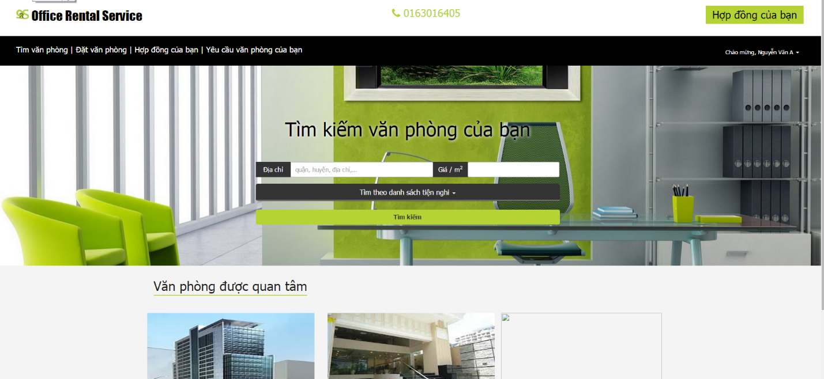

**Figure 167 : Request Office – step 1**

|  |  |
| --- | --- |
| **Step** | **Description** |
| 1 | Click “Đặt văn phòng” on menu bar |

**Table 98: Request Office – step 1**

##### **Request Office – step 2**

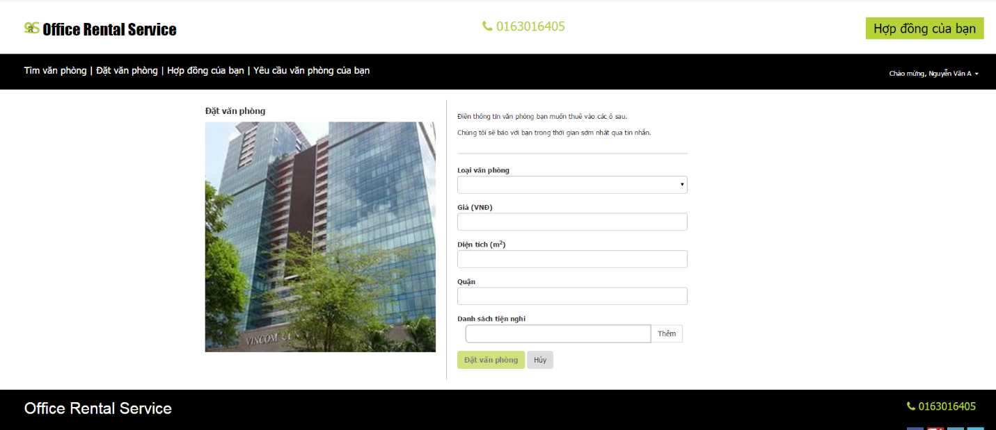

**Figure 167 : Request Office – step 2**

|  |  |
| --- | --- |
| **Step** | **Description** |
| 1 | Input info about “Loại văn phòng”, “Giá”, “Diện tích”, “Quận”, “Danh sách tiện nghi”. |
| 2 | Click “Đặt văn phòng” button |

**Table 98: Request Office – step 2**

#### Manager

##### **Create Contract – step 1**

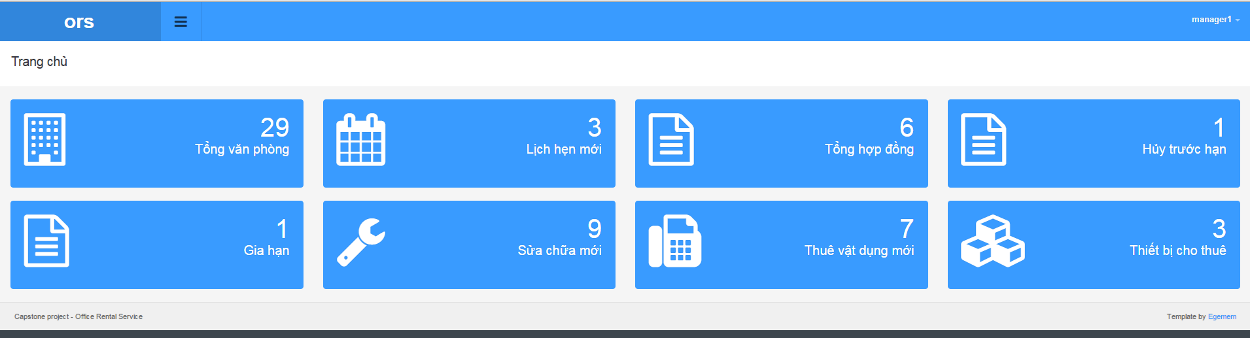

**Figure 167 : Create Contract – step 1**

|  |  |
| --- | --- |
| **Step** | **Description** |
| 1 | Click “Lịch hẹn mới” on admin home page |

**Table 98: Create Contract – step 1**

##### **Create Contract – step 2**

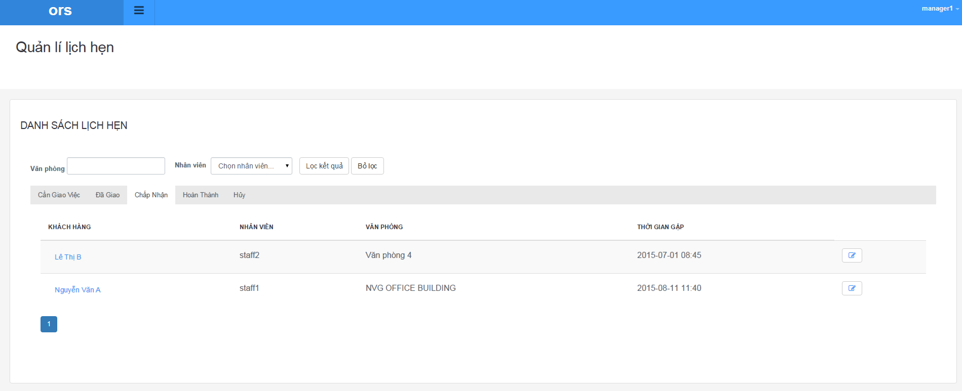**Figure 167 : Create Contract – step 2**

|  |  |
| --- | --- |
| **Step** | **Description** |
| 1 | Click “Chấp nhận” tab on tab bar |
| 2 | Click Edit button on each row |

**Table 98: Create Contract – step 2**

##### **Create Contract – step 3**

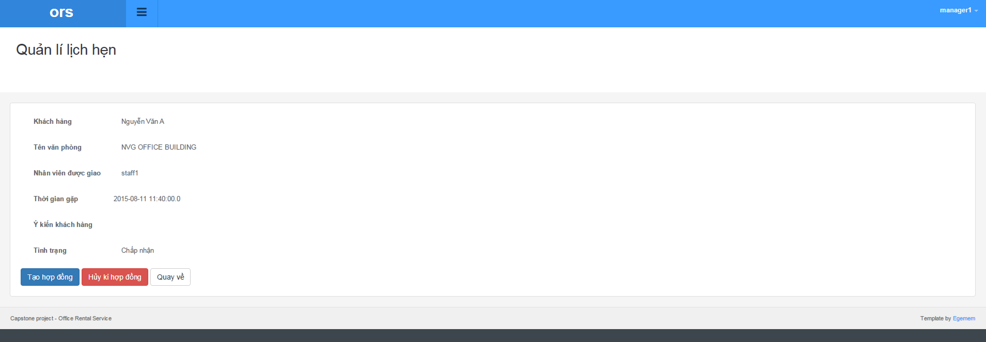

**Figure 167 : Create Contract – step 3**

|  |  |
| --- | --- |
| **Step** | **Description** |
| 1 | Click “Tạo hợp đồng” button |

**Table 98: Create Contract – step 3**

##### **Create Contract – step 4**

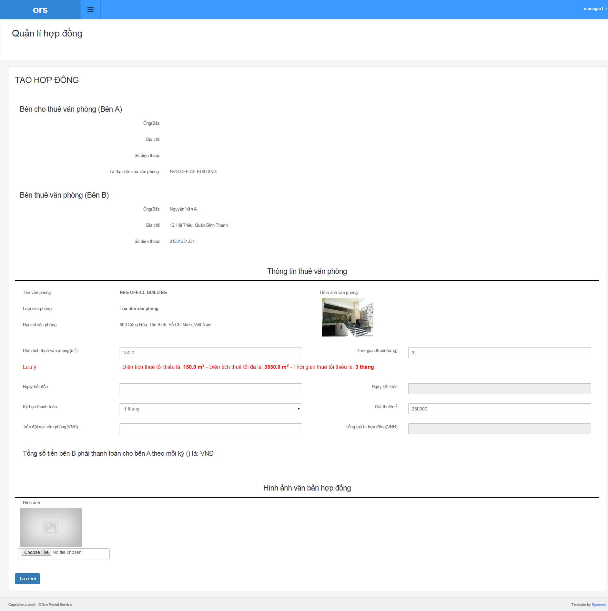

**Figure 167 : Create Contract – step 4**

|  |  |
| --- | --- |
| **Step** | **Description** |
| 1 | Input info for new contract |
| 2 | Click “Tạo mới” button |

**Table 98: Create Contract – step 4**

##### **Assign Appointment**

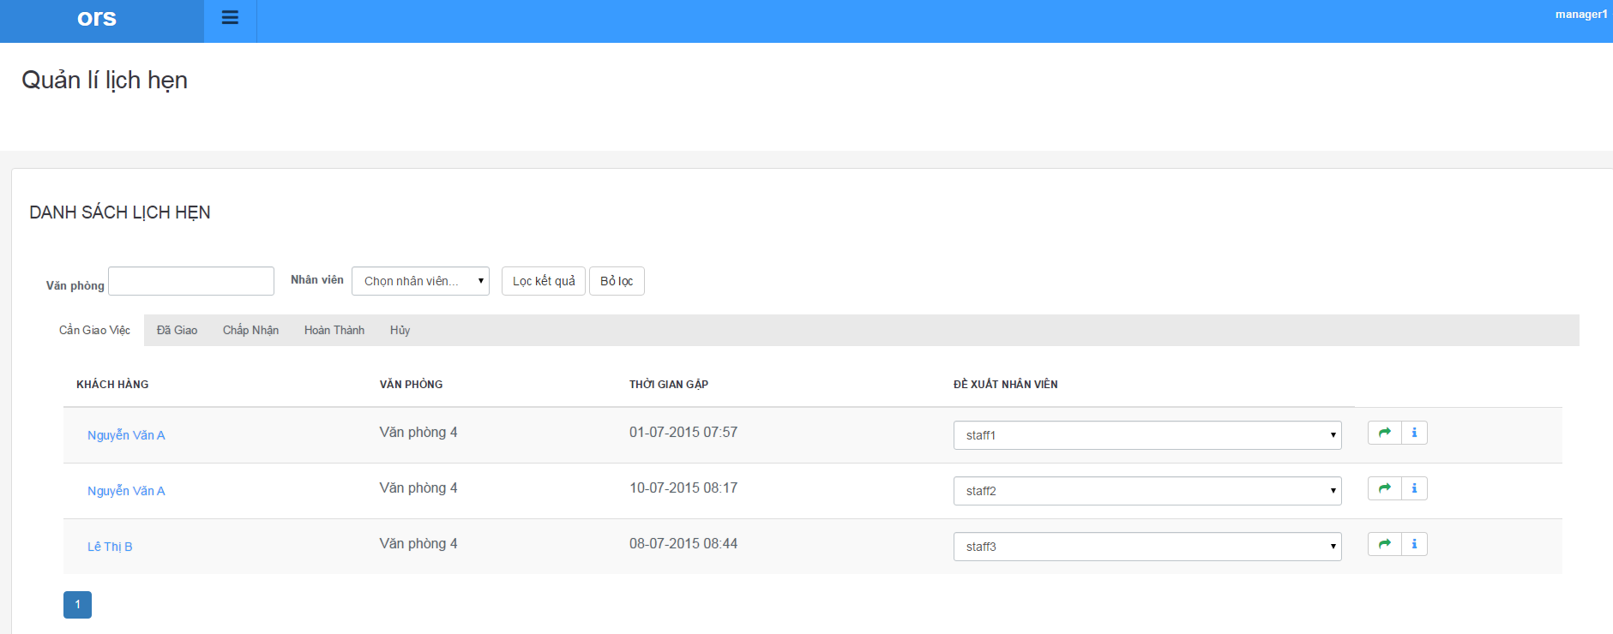

**Figure 167 : Assign Appointment**

|  |  |
| --- | --- |
| **Step** | **Description** |
| 1 | Select staff or let it default |
| 2 | Click assign button |

**Table 98: Assign Appointment**

##### **Assign Repair**

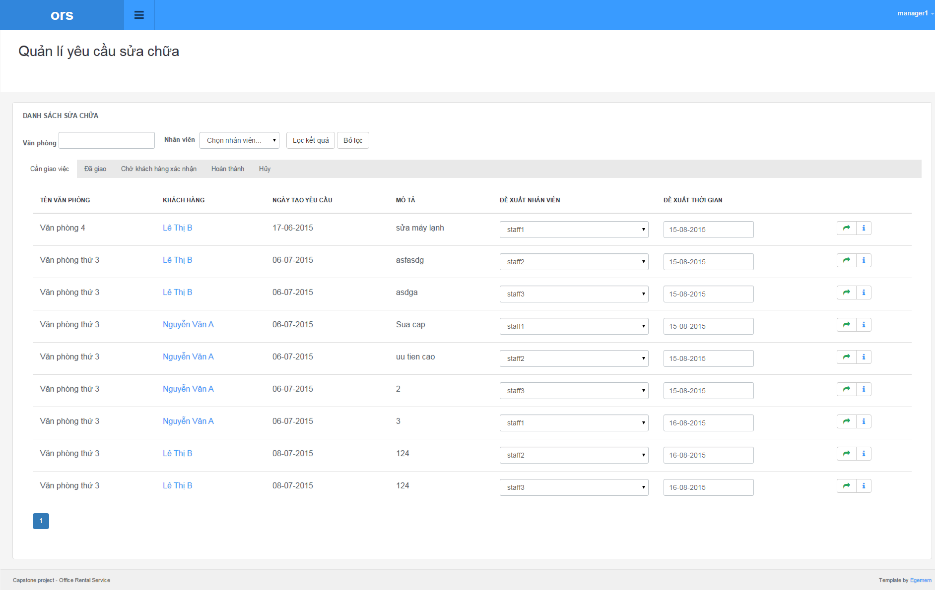

**Figure 167 : Assign Repair**

|  |  |
| --- | --- |
| **Step** | **Description** |
| 1 | Select staff or let it default |
| 2 | Choose date for repairing |
| 3 | Click assign button |

**Table 98: Assign Repair**